TOURISM: JULY 4 SPECTACLE TO BENEFIT ARMED SERVICES YMCA

Big Bay Boom Returning to San Diego Bay
By Brad Graves
Thursday, June 30, 2022

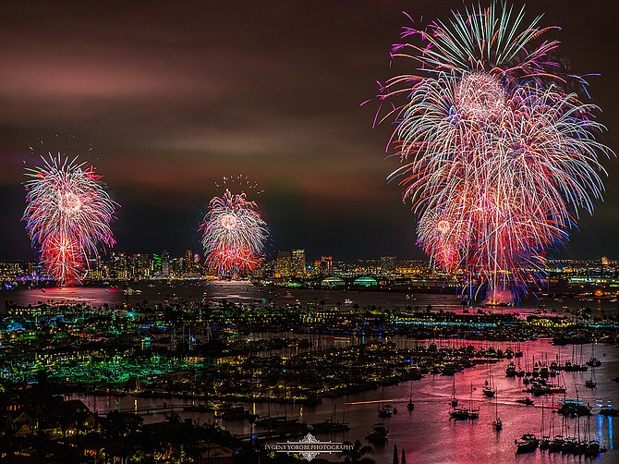
Independence Day fireworks fill the skies and cast a glow on the surface of San Diego Bay. Visitors will be able to enjoy the Big Bay Boom again on July 4. Photo by Evgeny Yorobe, courtesy of Big Bay Boom
With the Fourth of July on its way, organizers of the Big Bay Boom fireworks show are preparing for another spectacle in the skies over San Diego Bay.
COVID will not preempt this year’s show, as it did in 2020.
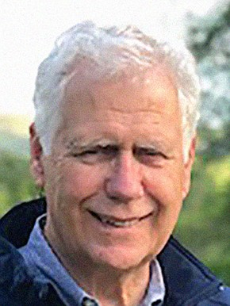
Sandy Purdon Executive Producer Big Bay Boom
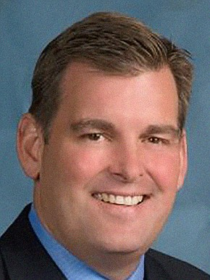
Dan Malcolm Chairman Board of Port Commissioners
This year’s pyrotechnic display is set for 9 p.m. on Monday, July 4, and will be visible from many parts of the San Diego Bayfront. Fireworks will be set off from four barges anchored near Shelter Island, Harbor Island, North Embarcadero and South Embarcadero.
The fireworks will be choreographed to music playing on radio station KGB, at 101.5 FM.
Some 400,000 people are expected to watch the show.
Funds raised from the show benefit the Armed Services YMCA and its programs for military personnel stationed locally as well as their families.
The Port of San Diego is title sponsor for the event.
“The Port of San Diego is proud to sponsor the Big Bay Boom,” said Dan Malcolm, chairman of the Board of Port Commissioners. He called the annual event “an incredible economic boost for businesses that operate on and around San Diego Bay.”
Supply Chain Snags
“We think we have as good a show as we’ve ever had,” said Sandy Purdon, executive producer of the event, who noted that show organizers “have been challenged getting good pyrotechnics due to the slow delivery of containers around the world.”
He added: “We always have new shots to entertain the viewers and this year will be no different.”
The fireworks show will be broadcast on Fox 5 San Diego.
The fireworks show has been credited with generating $10.1 million worth of direct sales among the region’s hotels, restaurants, shops, tour operators, museums, charter cruise operators and boat rental companies. The figure comes from a 2018 study conducted by the Fermanian Business & Economic Institute at Point Loma Nazarene University.
The lion’s share — $8.4 million — went to hotels, including their on-site restaurants and shops. Restaurants not counted in that category had another $713,000 in sales. Retail, harbor tours, transportation and attractions had combined sales of $596,000. Companies running parking lots had $363,000 in sales.
Venues on the water saw the greatest impact, though businesses within a 5-10 mile radius of the bay also saw an economic bump.
The event is televised in other California cities, giving San Diego’s visitor industry some welcome media exposure.
51,000 Served
In 2018, the Big Bay Boom raised $82,000 for Armed Services YMCA.
In its annual report for 2021, the Armed Services YMCA reported serving more than 51,000 service members and their families. Services include camps and childcare, family activities, services for people with a spouse on deployment and support for injured veterans. The organization has its main office at 3293 Santo Road, near the Murphy Canyon military housing complex, and a second office at Naval Medical Center San Diego in Balboa Park.
In addition, the organization offers equestrian activities through its Horse of the Sun Ranch in Pine Valley. Tim Ney is executive director of the local Armed Services YMCA.
The nonprofit had a $2.74 million budget in 2021, according to its annual report. Some $1.67 million of income came from monetary donations.
The combined Armed Services YMCA of the USA, based in Virginia with locations nationwide, reported $15.7 million in revenue during 2020, according to federal filing.
Viewers Should Plan Ahead
The port said that parking will be at a premium near the bay on July 4, and roads to Shelter Island and Harbor Island might be closed. It encouraged viewers to use rideshare services or take public transportation to the bayfront fireworks show. Trolley stations located near prime viewing spots include County Center/Little Italy, Santa Fe Depot, One America Plaza, Seaport Village, Convention Center and Gaslamp Quarter.
Boaters are advised not to get within 1,000 feet of the barges setting off the fireworks.
The port prohibits open containers of alcohol in its parks and on the bayfront.
More information on the show, including transportation tips, is at bigbayboom.com.
Port of San Diego
FOUNDED: 1962
PRESIDENT/CEO: Joe Stuyvesant
HEADQUARTERS: Middletown
BUSINESS: Government agency, owner and lessor of land on San Diego Bay, operator of cargo and cruise terminals
EMPLOYEES: 542
REVENUE: Operating revenues of $143.6 million in fiscal year ended June 30, 2021
WEBSITE: portofsandiego.org
CONTACT: 619-686-6200
SOCIAL IMPACT: The port district is working to upgrade and expand Pepper Park on the Sweetwater Channel to benefit South Bay residents. A first set of improvements is scheduled to be finished by mid-2024.
NOTABLE: The port handled 4.35 million tons of cargo in 2021, according to the Pacific Maritime Association

